1- Down Time Analytics
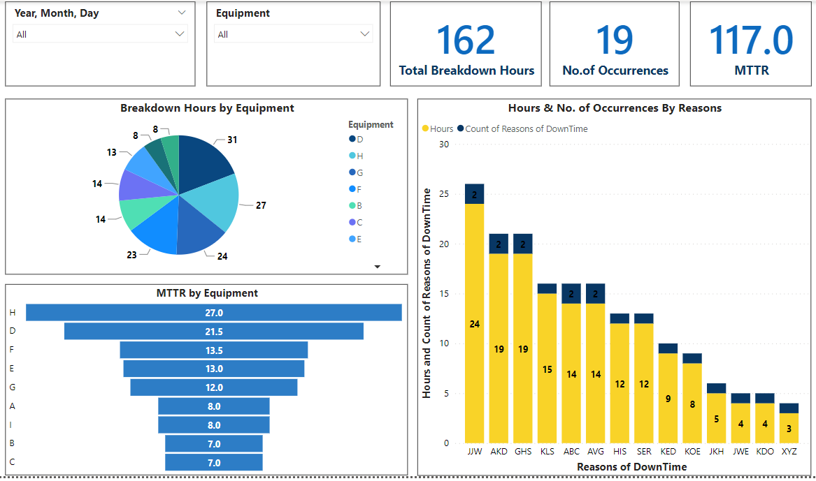

The screenshot above is of the DownTime Dashboard. Equipment downtime is the time that equipment is not operating, whether that’s a result of unplanned equipment failure (like a fault or broken part) or planned downtime (like necessary downtime for preventive maintenance).
This deck includes the following potential KPIs:
- Breakdown Hours
- No. of Occurrences, the downtime has occurred
- MTTR

Downtime Hours by the Equipment:
Although equipment downtime costs businesses enormous amounts of money, however, it cannot be completely avoided, and efforts should be made to reduce its occurrences. Because it affects how an organization uses its maintenance resources, tracking it is crucial. Allocating resources to the proper maintenance tasks reduces costs and saves time.

Downtime Hours & No.of Occurrences by DownTime Reasons:
Whenever a downtime has occurred whether it's planned or unplanned, there could be several causes or reasons why an equipment goes towards downtime or failure. These reasons can occur a single or multiple times but what matters is how frequent these breakdowns are and how long it's taking to get it repaired while ensuring that it's available to use.

Mean Time to Repair:
It is a metric used to measure how well equipment or services are being maintained, and how quickly issues are being responded to. It’s also a valuable way to assess the value of equipment and make better decisions about asset management.
If MTTR increases over time, this may highlight issues with your processes or equipment, and if it goes down, then it may indicate that your service level to your customers is improving.
With the rapid pace of life and business these days, responding as quickly as possible to issues when they arise can sometimes mean the difference between keeping and losing a customer.

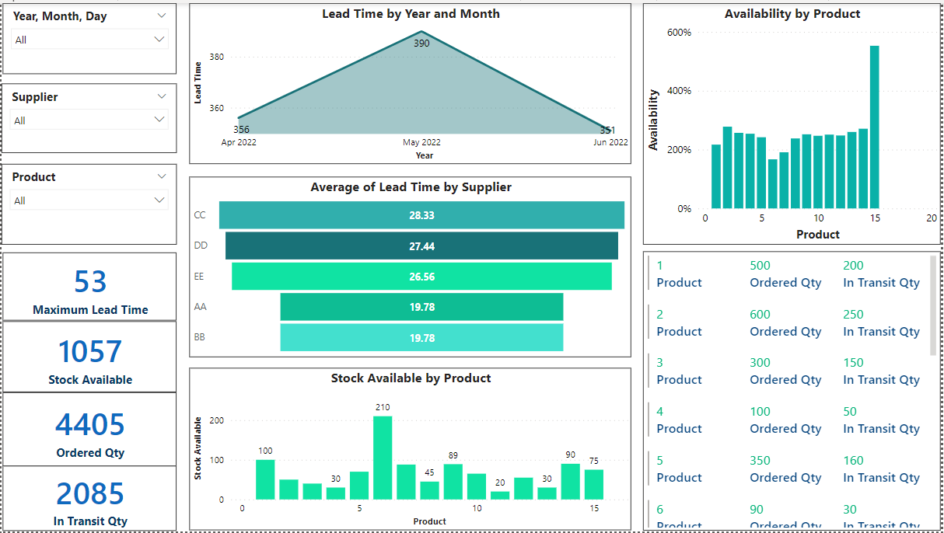
2- Purchasing Performance Analytics
The screenshot mentioned above represents the information about Purchasing performance indicators. Purchasing KPIs may be created in conjunction with supplier metrics in order to measure the performance elements of the procurement process. Procurement performance indicators help organizations to optimize and regulate their purchase expenses, quality, cost, and time.

Lead Time:
Lead time refers to the capacity to fulfill an order, from the initiation to the execution of the process, expressed in days. The lead time differs from purchase order cycle time because it encompasses the whole process until the delivery. If the lead time keeps on growing, measures should be taken to address the potential issues.

Suppliers Availability:
The supplier availability refers to the number of times goods were available on the supplier’s side, or to the number of orders placed with the supplier. It is important to manage suppliers as efficiently as possible to guarantee the availability of stocks. By monitoring the evolution of your supplier’s availability of stocks, you know the degree of reliability you can place in them.

Inventory Management:
Inventory management are metrics that help you monitor and make decisions about your stock. By discovering problem areas, leaders can implement process adjustments and track their improvement. Businesses assess inventory management using different metrics for different business operations. Categorizing KPIs by operation type lets leaders focus on areas in need of change. Some of the inventory management KPIs used here are as follows:
- Current stock available
- Number of Ordered Qty
- Number of Stocks that are in Transit

3- Project Overall Efficiency:

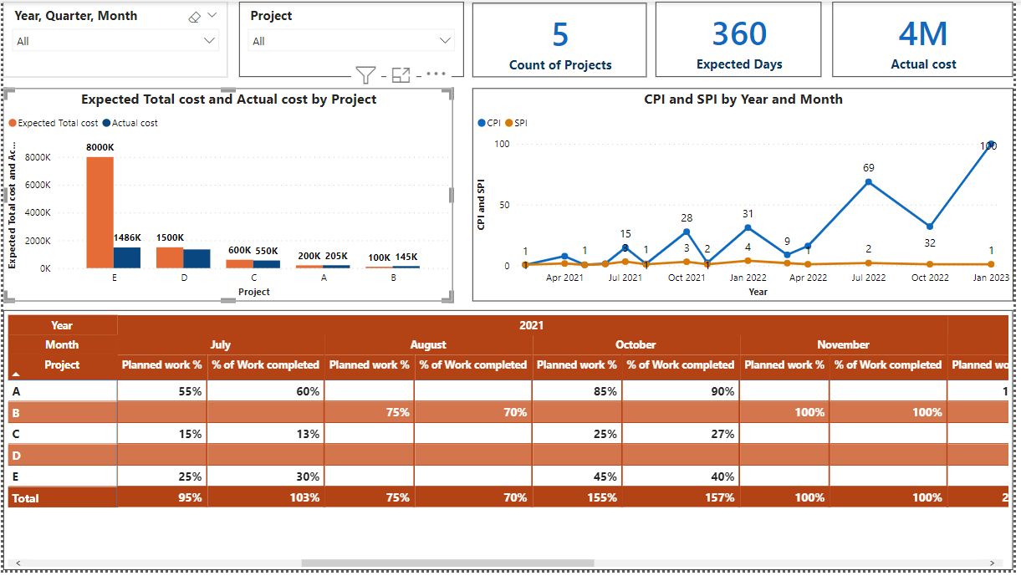

This deck shows the overall efficiency of all the projects along with relevant KPI’s. For instance, the count of projects, number of budgeted days, total vs actual cost spent, Cost Performance Index (CPI), Scheduled Performance Index (SPI), and percentage of planned vs actual work completed based on different timelines of each project are the key potential indicators. However, the two most crucial project metrics are performance against schedule and performance against budget. We may evaluate the effectiveness of any project using SPI and CPI.

Budgeted Cost:
The Expected Total Cost is the amount of money that has been estimated by the team at the planning stage of the project.

Actual Cost:
The Actual Cost is the amount of money that has been spent on the project with respect to the time. These costs cover the entire cost being utilized.

Cost Performance Index:

A project's efficiency and financial efficacy are gauged by the cost performance index (CPI).It represents the amount of completed work for every unit of cost spent. The result indicates the relative scale of deviations which helps assess their criticality.
When the CPI ratio is more than 1, a project is functioning well financially. A CPI value of 1 indicates that a project is performing on budget. A CPI value that is less than 1 indicates that a project is over budget.

Schedule Performance Index:
The Scheduled Performance Index (SPI) measures your performance about the project's original schedule. Depending on the integer, SPI reflects a project being on schedule, behind schedule, or ahead of schedule. The schedule performance index is especially helpful for calling attention to issues before they worsen. If a project is falling behind schedule, the SPI will reflect this and indicate changes that need to be made.
SPI > 1: The project is ahead of schedule; more work has been completed than expected.
SPI < 1: The project is behind schedule; less work has been done than planned.
SPI = 1: The project is on schedule; earned value and planned value are equal.

Planned vs Work Completion %:
The purpose of measuring this KPI is to track the overall progress of the project. The percentage of the planned work indicates how much amount of work needs to be done in that time whereas work completed shows the completion of work after a fixed duration of time.

4- Project Overview Deck:
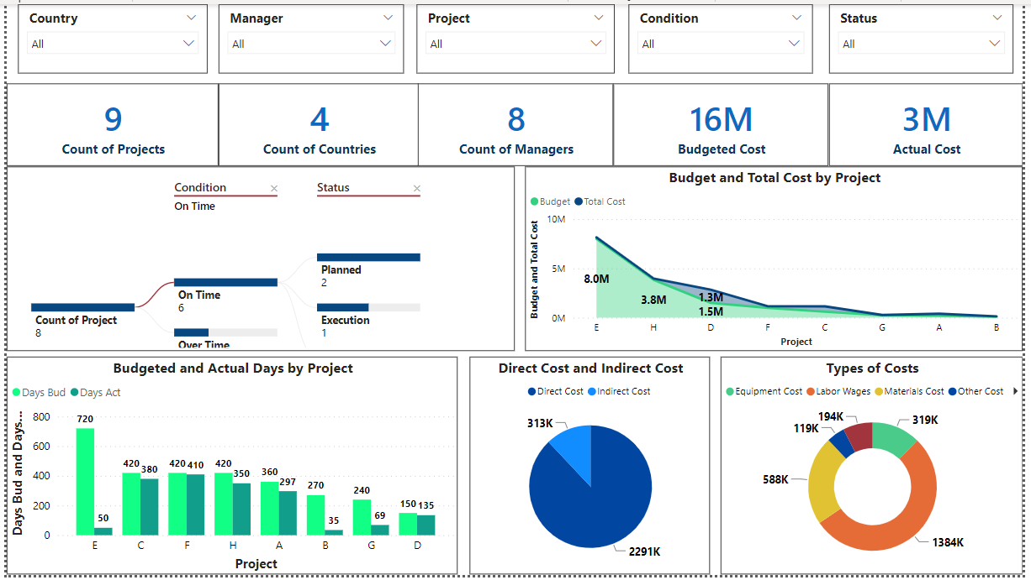
Project overview covers major project KPIs such as count of projects, countries, managers and cost. The above-attached dashboard provides a general overview of the project statistics of the company within the specified time period.
Count of projects the total number of projects dealt with by the company regardless of their status. The count of countries shows the number of countries the projects belong to. The count of managers shows the number of managers leading the projects. The dashboard can be filtered such as to show the projects within a specified country or the overview of all projects led by a particular manager.

Status Breakdown
The status breakdown shows the number of projects according to the condition of project progress being on time or overtime. Furthermore, it shows the number of projects according to the status of planning, execution and finishing, etc.

Budgeted and Total Cost
The comparison of the budgeted cost of a project and the total cost incurred is to track the project’s cost and whether the cost exceeds the budget or lies within the budgeted values.
The cost of projects is split into direct and indirect costs which are further split into labor cost, materials cost, etc. Detailed cost tracking provides visibility on project spending to help understand the cost of various categories relative to the project.

Budgeted and Actual Days
It is used to track and compare the number of days worked on a project and its planned working days. This allows us to observe the progress of the project and the work done by workers as assigned. It can also help highlight the projects that require more days to complete work as compared to the previously budgeted time.

5- Project Cost Analytics:
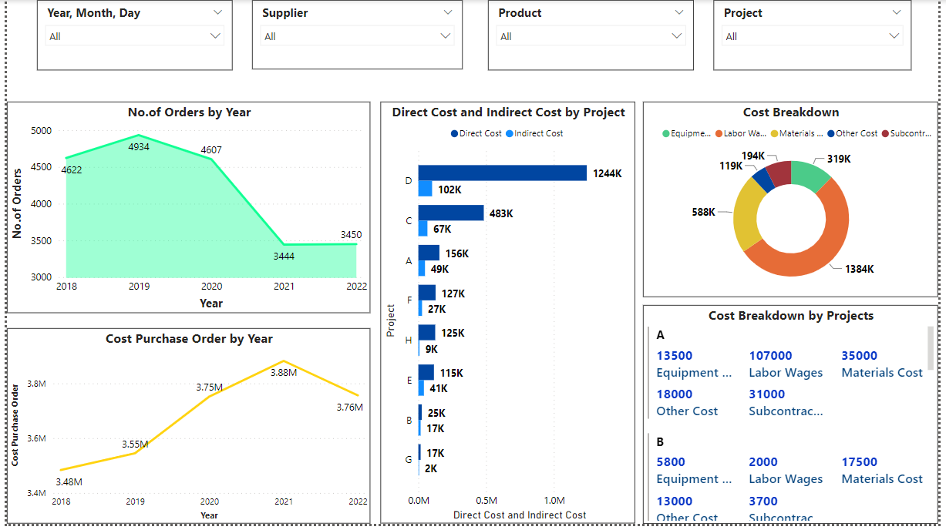
Project cost analytics dashboard provides a thorough understanding of the costs incurred on the project. It includes the number of orders made and the cost of purchased orders, along with the direct and indirect costs of the projects and their breakdown

No. of Orders and Purchase Cost by Year
It shows the no. of orders made each year for construction materials and costs of purchase orders. Tracking orders placed shows the demand for construction materials and its relationship with the projects in progress. Cost of purchase orders can be analyzed alongside a particular project to understand the demand for relevant equipment and materials.

Direct and Indirect Cost
The costs of the project and majorly split into two categories direct and indirect. The direct cost covers the costs which are directly attributed to the project while the indirect cost is not directly related to the project.

Cost Breakdown
The direct cost is split into materials cost, labor wages, and equipment costs, while the indirect cost is split into subcontractor's wages and other costs such as rent, etc. Detailed cost breakdown provides visibility on project spending to help understand the cost of various categories relative to the project.

6- Project Details:
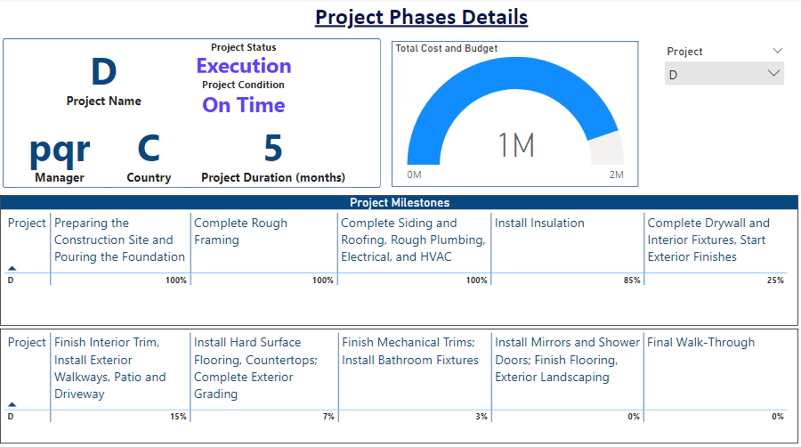
Project details describe thorough information about a particular project. These include information about project status, duration, budget, and milestones.

Project Information
It shows the name of the project under consideration, its country, and the manager assigned to the project. Status of the project such as planning, execution, and finishing is also included. The project duration tells the planned number of months for the project and whether the project is on time or delayed.

Cost and Budget
Comparison between the cost incurred for the project and its total budgeted value keeps track of the project’s spending and whether it is within the budget threshold.

Project Milestones
Project milestones tables show the percentage of each milestone completed within the project. Milestones track the progress of the project and help understand the scope of work remaining. The percentage completion of each milestone determines the status of the project.

